AI Assistant Coding
Kothuri Rishitha
Batch-23
2303A51680

Question 1: Zero-Shot Prompting (Leap Year Check)
Write a zero-shot prompt to generate a Python function that checks
whether a given year is a leap year.
Task:
• Record the AI-generated code.
• Test with years like 1900, 2000, 2024.
• Identify logical flaws or missing conditions.
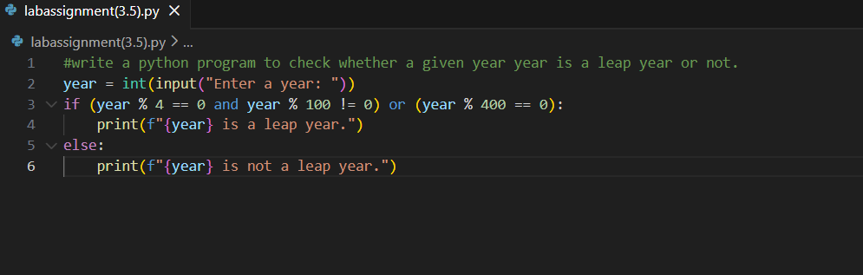
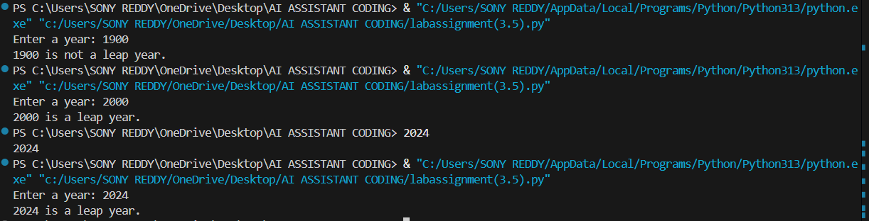
Question 2: One-Shot Prompting (GCD of Two Numbers)
Write a one-shot prompt with one example to generate a Python
function that finds the Greatest Common Divisor (GCD) of two numbers.
Example:
Input: 12, 18 → Output: 6
Task:
• Compare with a zero-shot solution.
• Analyze algorithm efficiency.
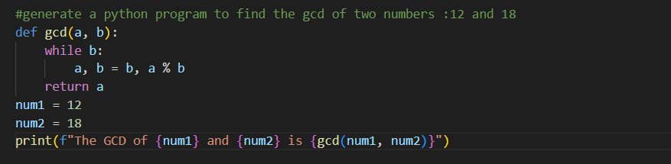
Question 3: Few-Shot Prompting (LCM Calculation)
Write a few-shot prompt with multiple examples to generate a Python
function that computes the Least Common Multiple (LCM).
Examples:
• Input: 4, 6 → Output: 12
• Input: 5, 10 → Output: 10
• Input: 7, 3 → Output: 21
Task:
• Examine how examples guide formula selection.
• Test edge cases.
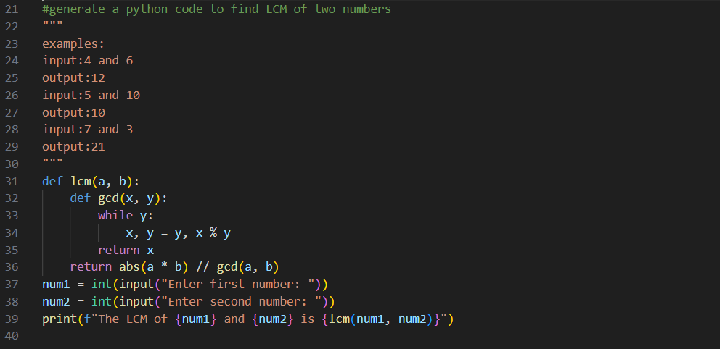
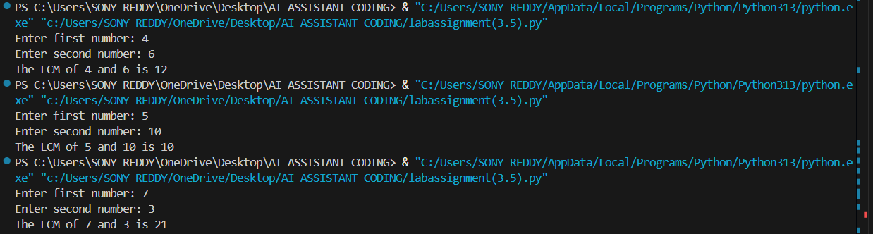

Question 4: Zero-Shot Prompting (Binary to Decimal Conversion)
Write a zero-shot prompt to generate a Python function that converts a
binary number to decimal.
Task:
• Test with valid and invalid binary inputs.
• Identify missing validation logic.
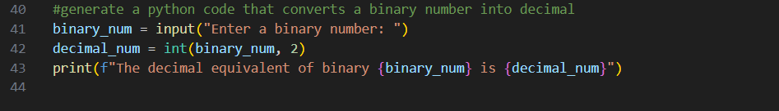
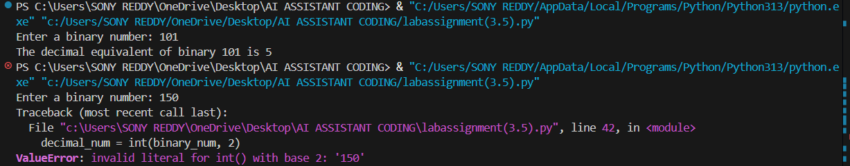

Question 5: One-Shot Prompting (Decimal to Binary Conversion)
Write a one-shot prompt with an example to generate a Python function
that converts a decimal number to binary.
Example:
Input: 10 → Output: 1010
Task:
• Compare clarity with zero-shot output.
• Analyze handling of zero and negative numbers.
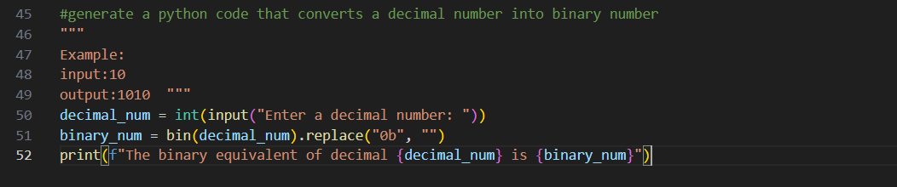
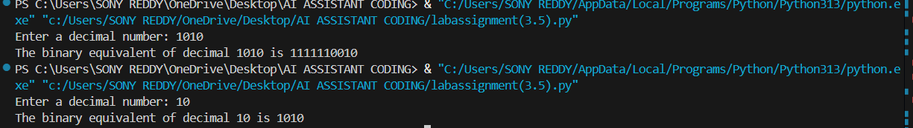

Question 6: Few-Shot Prompting (Harshad Number Check)
Write a few-shot prompt to generate a Python function that checks
whether a number is a Harshad (Niven) number.
Examples:
• Input: 18 → Output: Harshad Number
• Input: 21 → Output: Harshad Number
• Input: 19 → Output: Not a Harshad Number
Task:
• Test boundary conditions.
• Evaluate robustness
